**Project Design Phase-II Data Flow Diagram & User Stories**

|  |  |
| --- | --- |
| **Date** | **22 October 2022** |
| **Team ID** | **PNT2022TMID08105** |
| **Project Name** | **Analytics for Hospital’s Health-Care Data** |
| **Maximum Marks** | **4 Marks** |

**Data Flow Diagrams:**

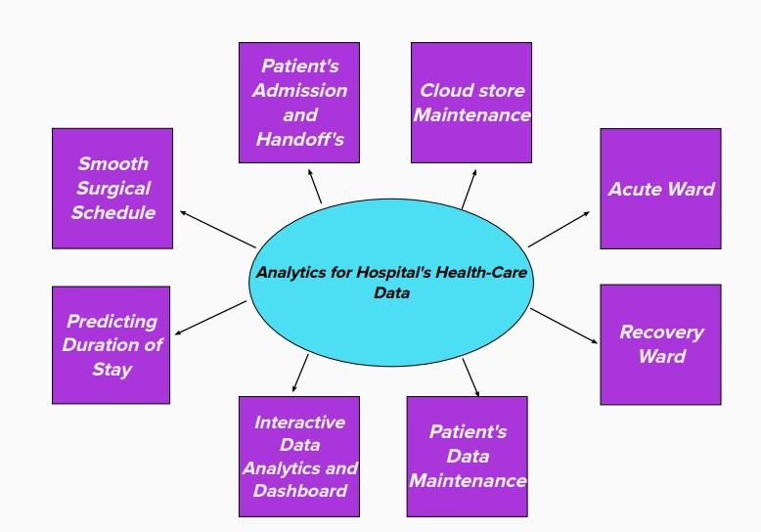

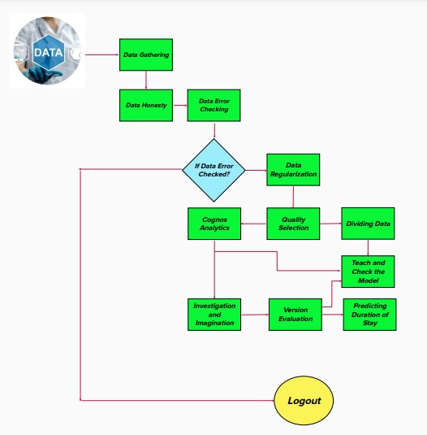

|  |  |  |  |  |  |  |
| --- | --- | --- | --- | --- | --- | --- |
| **User Type** | **Functional**  **Requirement**  **(Epic)** | **User**  **Story**  **Number** | **User Story/Task** | **Acceptance**  **Criteria** | **Priority** | **Release** |
| Customer  (Mobile user) | Registration | USN-1 | Asa user,I can sign in for the application entering my email,password | I can access my account dashboard | High | Sprint-1 |
|  |  |  | As a user, I can sign up for the application through google |  | High | Sprint-1 |
|  |  | USN-2 | As a user, I will receive confirmation email | I can click confirmation email | High | Sprint-1 |

**User Stories:**

|  |  |  |  |  |  |  |
| --- | --- | --- | --- | --- | --- | --- |
|  |  | USN-3 | As a user, I can register for the application through Instagram | I can access the dashboard with Instagram  Login | Low | Sprint-2 |
|  |  | USN-4 | As a user, I can register for the application to know the length of stay of patients | I can access patient’s data based on their severeness | High | Sprint-1 |
|  | Login | USN-5 | As a user, I can log into the  application by entering user id &  password |  | High | Sprint-1 |
|  |  | USN-6 | As a user I can explore the all the  details regarding to hospital in my  dashboard |  | Medium | Sprint-2 |
| Administra tor | Updating data | USN-7 | As a user I can collect the data of all the patients from their attendees and I can store it | I can check the gathered  data and can  store it | High | Sprint-1 |
|  |  | USN-8 | As a Administrator I can categorize the patients based on their risk factors |  | High | Sprint-1 |
| Customer (Web User) | Accessing the resources | USN-9 | As a user I can get all the informations in the dashboard | These resources cannot be accessed by  others but only  me | High | Sprint-1 |
| Customer  tools | Tools | USN-10 | As a user I can explore the data through data visualization tools like Cognos analytic |  | High | Sprint-2 |